St. Edward the Confessor Parish School
2nd Annual Catholic Book and Gift Fair!
(Sponsored by Mary's Corner Gift Shop)
Wednesday, April 17 - Friday, April 19
In the School Library Media Center
Gifts for First Holy Communion & Mother's Day
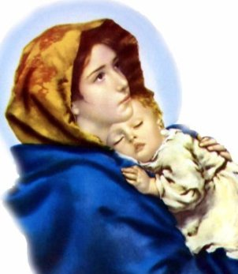

More than just books, Mary’s Corner offers an
extensive collection of gifts for all ages,
sacramental, home décor, and much more.

• Rosaries in every style and price range
• Gifts for Baptism, First Communion, Confirmation
• Nice selection of Fontanini statues
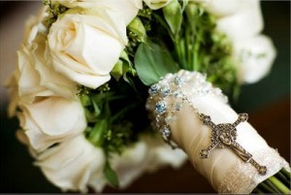
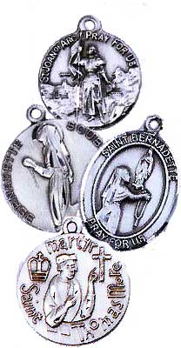
• Patron Saint medals in Italian oxidized silver
• Framed and unframed religious art
• Crucifixes, crosses, and holy water fonts
• Music CDs, DVDs
• Educational materials and Christian jewelry
• Items for infants and young children

When: Wednesday, April 17th through Friday, April 19th

Time: 8 a.m. - 30 minutes after school

Where: School Library Media Center

Please note: we can only accept checks or cash. Thank you!

Special orders are always welcome!
Wonderful gifts for First Holy Communion, Baptism, and Mother’s Day. (Special Orders will take a few days to arrive)

